<<COURT_NAME>>

|  |  |
| --- | --- |
| <<PROVIDER_SUITNAME>>,  a/a/o <<INJUREDPARTY_NAME>>    Plaintiff,  vs.  <<INSURANCECOMPANY_SUITNAME>>  Defendant. | Case No. <<INDEXORAAA_NUMBER>> |

__________________________________________/

**NOTICE OF VOLUNTARY DISMISSAL**

Plaintiff, <<PROVIDER_SUITNAME>> a/a/o <<INJUREDPARTY_NAME>>, by and through the undersigned counsel, hereby dismisses this action against Defendant, <<INSURANCECOMPANY_SUITNAME>> without prejudice. The Parties shall bear their own fees and costs as per the terms of the settlement agreement. The Court shall reserve jurisdiction to enforce the terms and conditions of the settlement agreement.

**CERTIFICATE OF SERVICE**

I HEREBY CERTIFY that on ­­­­­­­­­­­­­February 20, 2022, a true and correct copy of the foregoing was filed and served on the Defendant through the Florida E-File Portal.

The Florida Insurance Law Group, LLC

8724 Sunset Drive, #260, Miami, FL 33173

Tel. (305) 906-4262

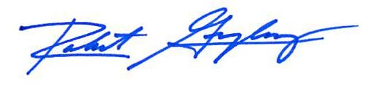

Robert F. Gonzalez, Esq.

Fla. Bar No. 68865

[Pleadings@flinslaw.com](mailto:Pleadings@flinslaw.com)